Welcome to Worship!
July 28, 2024 Proper 12

Greeting and Call to Worship
Prelude

*Responsive Call to Worship based on psalm 145
Leader: The Lord is gracious and merciful, slow to anger and abounding in steadfast love.
People: The Lord is good to all, and his compassion is over all that he has made.
Leader: ll your works shall give thanks to you, O Lord, and all your faithful shall bless you.
People: They shall speak of the glory of your kingdom and tell of your power,
Leader: to make known to all people your mighty deeds and the glorious splendor of your kingdom.
People: Your kingdom is an everlasting kingdom, and your dominion endures throughout all generations.
Leader: The Lord is faithful in all his words and gracious in all his deeds.
People: The Lord upholds all who are falling and raises up all who are bowed down.

Opening Hymn: “Wonderful Grace of Jesus” No. 362

*Unison Prayer of Invocation and Lord’s Prayer (debts)
Lord, we come to you needing to be fed, taught, and healed, but we don't know how or why. Help us understand that we must be your hands and heart here on earth, and let us be the ones who bless what you have already given and done, just as Jesus did when he prayed ...... Our Father, who art in heaven, hallowed be thy name. Thy kingdom come, thy will be done on earth as it is in heaven. Give us this day our daily bread, and forgive us our debts, as we forgive our debtors. And lead us not into temptation, but deliver us from evil. For thine is the kingdom, and the power, and the glory forever. Amen

*Gloria Patri No. 734
Glory be to the Creator, and to the Christ: And to the Holy Ghost;
As it was in the beginning, is now and ever shall be: world without end. Amen.

Reading of the Word John 6:1-21; Eph 3:14-21

Sermon “Well, THAT Was Unexpected...”

Meditation Hymn: “Day by Day” No. 449

Prayers of the People

Call For The Offering
Offertory
You may also mail your offering (P.O. Box 128, Greenland, NH 03840); Give on line by going to greenlanducc.org and click "Donate" tab. Thank you!

*Doxology No. 34
Praise God, from whom all blessings flow:
Praise God, all creatures here below.
Praise God above, ye heavenly host;
Creator, Christ, and Holy Ghost. Amen

*Prayer of Dedication

*Closing Hymn: “Let There Be Peace on Earth” No. 614

*Benediction

Postlude

*Please stand if you are able



The greeters/ushers today are Barbara and Jon Fletcher.

The liturgist today is Jon Fletcher.

Today’s guest Music Director is Joshua Tomlinson.

The flowers are given by Katie Wentworth in celebration of her daughter Hillary's birthday.

Community Congregational Church (UCC)
Greenland, New Hampshire
Gathered in 1706
Pastor: Rev. Mark C. Brockmeier
Music Director: Adelyn Nelson

Ministers: All the members of this congregation
Follow us on Facebook: https://www.facebook.com/cccgreenland
Church Office: 44 Post Rd. Open Wednesdays 12-7
PO Box 128 Greenland NH 03840
603-436-8336, greenlanducc@myfairpoint.net
Rev. Mark Brockmeier email: revbrock@bu.edu
Mobile: 603-818-2328

July 28, 2024 Proper 12
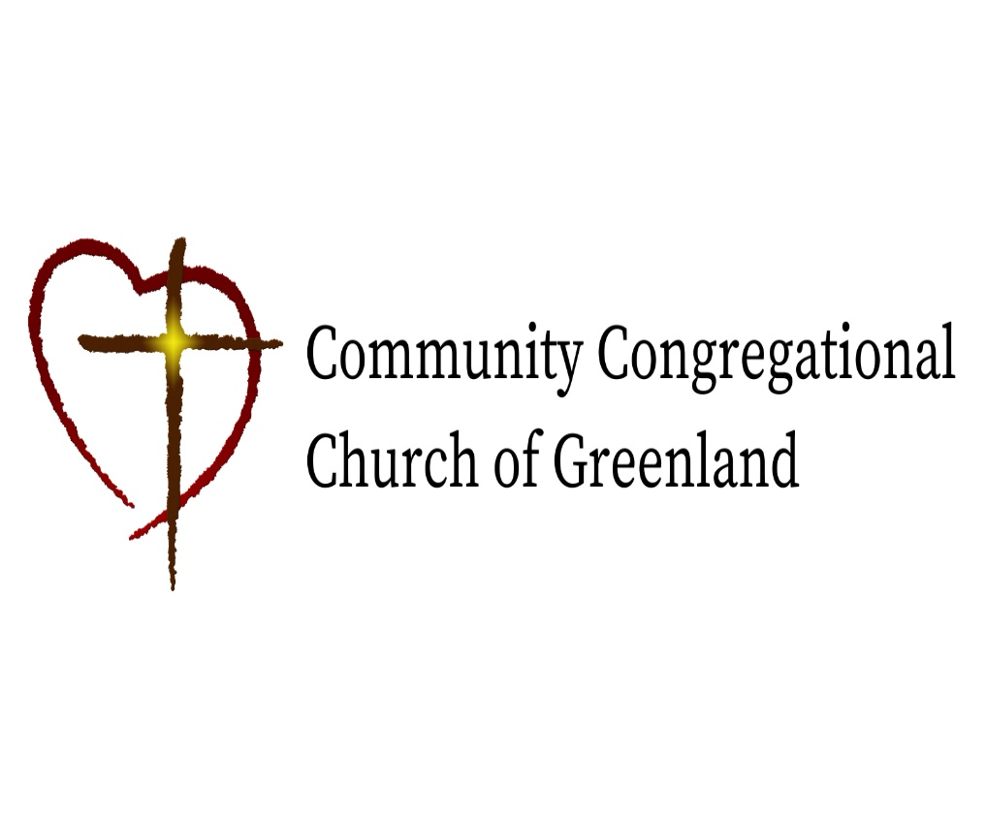

God calls us together to welcome all
and to serve God, each other, this community,
and the world
in the spirit of Christ’s love.
❖ All are welcome! 

