Welcome to Worship!
July 14, 2024 Proper 10

Greeting and Call to Worship
Prelude

*Responsive Call to Worship based on psalm
Leader: The earth is the Lord’s and all that is in it, the world,
and those who live in it,
People: for he has founded it on the seas and established it
on the rivers.
Leader: Who shall ascend the hill of the Lord? And who shall stand in his holy place?
People: Those who have clean hands and pure hearts, who
do not lift up their souls to what is false and do not swear deceitfully.
Leader: They will receive blessing from the Lord and vindication from the God of their salvation.
People: Such is the company of those who seek him, who seek the face of the God of Jacob.

Opening Hymn: “Shall We Gather at the River” No. 522

*Unison Prayer of Invocation and Lord’s Prayer (debts)
Lord, we are so focused on seeking and satisfying our wants we forget what that means to others. Remind us of the consequences of our actions, heal the hurts we project onto others, and assure in us the love Jesus gave when he taught us to pray, saying...... Our Father, who art in heaven, hallowed be thy name. Thy kingdom come, thy will be done on earth as it is in heaven. Give us this day our daily bread, and forgive us our debts, as we forgive our debtors. And lead us not into temptation, but deliver us from evil. For thine is the kingdom, and the power, and the glory forever. Amen

*Gloria Patri No. 734
Glory be to the Creator, and to the Christ: And to the Holy Ghost;
As it was in the beginning, is now and ever shall be: world without end. Amen.

Reading of the Word Mark 6:14-29; Eph 1:3-11

Sermon “What Did They Say?”

Meditation Hymn: “Abide With Me” No. 521

Prayers of the People

Call For The Offering
Offertory
You may also mail your offering (P.O. Box 128, Greenland, NH 03840); Give on line by going to greenlanducc.org and click "Donate" tab. Thank you!

*Doxology No. 34
Praise God, from whom all blessings flow:
Praise God, all creatures here below.
Praise God above, ye heavenly host;
Creator, Christ, and Holy Ghost. Amen

*Prayer of Dedication

*Closing Hymn: “Precious Lord, Take My Hand” No. 500

*Benediction

Postlude

*Please stand if you are able



The greeters/ushers today are Chris and Joanne Shultz.

The liturgist today is Bonnie Gardner.

Today’s guest Music Director is Joshua Tomlinson.

The flowers are given by Bev Perriccio Celebrating Denise's anniversary.

Community Congregational Church (UCC)
Greenland, New Hampshire
Gathered in 1706
Pastor: Rev. Mark C. Brockmeier
Music Director: Adelyn Nelson

Ministers: All the members of this congregation
Follow us on Facebook: https://www.facebook.com/cccgreenland
Church Office: 44 Post Rd. Open Wednesdays 12-7
PO Box 128 Greenland NH 03840
603-436-8336, greenlanducc@myfairpoint.net
Rev. Mark Brockmeier email: revbrock@bu.edu
Mobile: 603-818-2328

July 14, 2024 Proper 10
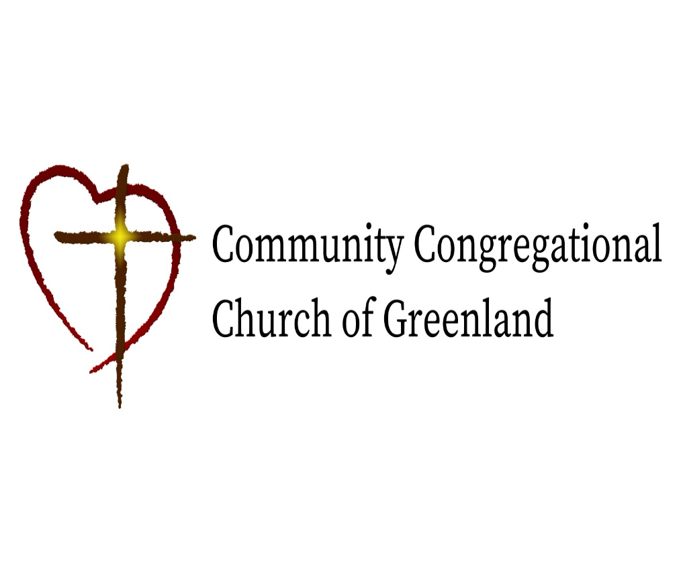

God calls us together to welcome all
and to serve God, each other, this community,
and the world
in the spirit of Christ’s love.
❖ All are welcome! 

