Welcome to Worship!
June 30, 2024 Proper 8

Greeting and Call to Worship
Prelude

*Responsive Call to Worship based on psalm 130
Leader: Out of the depths I cry to you, O Lord.
People: Lord, hear my voice! Let your ears be attentive
to the voice of my supplications!
Leader: If you, O Lord, should mark iniquities, Lord, who could stand?
People: But there is forgiveness with you, so that you may be revered.
Leader: I wait for the Lord; my soul waits, and in his word I hope;
People: my soul waits for the Lord more than those who watch for the morning, more than those who watch for the morning.

Opening Hymn: “O Christ, the Healer, We Have Come” No. 638

*Unison Prayer of Invocation and Lord’s Prayer (debts)
Lord, we fear for many things in this world, and it occupies much of our life and plans for the future. Help us to trust your Kingdom overcomes fear, and accept the invitation to come and be at rest, just as Jesus invited us when he taught us to pray, saying...... Our Father, who art in heaven, hallowed be thy name. Thy kingdom come, thy will be done on earth as it is in heaven. Give us this day our daily bread, and forgive us our debts, as we forgive our debtors. And lead us not into temptation, but deliver us from evil. For thine is the kingdom, and the power, and the glory forever. Amen

*Gloria Patri No. 734
Glory be to the Creator, and to the Christ: And to the Holy Ghost;
As it was in the beginning, is now and ever shall be: world without end. Amen.

Reading of the Word Mark 5:21-43; 2 Cor 8:7-15
Sermon “From Fear to Faith”

Meditation Hymn: “Healer of My Soul” No. 633

Prayers of the People

Call For The Offering
Offertory
You may also mail your offering (P.O. Box 128, Greenland, NH 03840); Give on line by going to greenlanducc.org and click "Donate" tab. Thank you!

*Doxology No. 34
Praise God, from whom all blessings flow:
Praise God, all creatures here below.
Praise God above, ye heavenly host;
Creator, Christ, and Holy Ghost. Amen

*Prayer of Dedication

*Closing Hymn: “Sent Forth by God's Blessing” No. 712

*Benediction

Postlude

*Please stand if you are able



The greeters/ushers today are Wendy Stanley Jones and Joanne Spradlin.

The liturgist today is Glenn Bergeron.

Today’s guest Music Director is Joshua Tomlinson.

The flowers are given by George and Sherri Becker honoring our country's birthday.

Community Congregational Church (UCC)
Greenland, New Hampshire
Gathered in 1706
Pastor: Rev. Mark C. Brockmeier
Music Director: Adelyn Nelson

Ministers: All the members of this congregation
Follow us on Facebook: https://www.facebook.com/cccgreenland
Church Office: 44 Post Rd. Open Wednesdays 12-7
PO Box 128 Greenland NH 03840
603-436-8336, greenlanducc@myfairpoint.net
Rev. Mark Brockmeier email: revbrock@bu.edu
Mobile: 603-818-2328

June 30, 2024 Proper 8
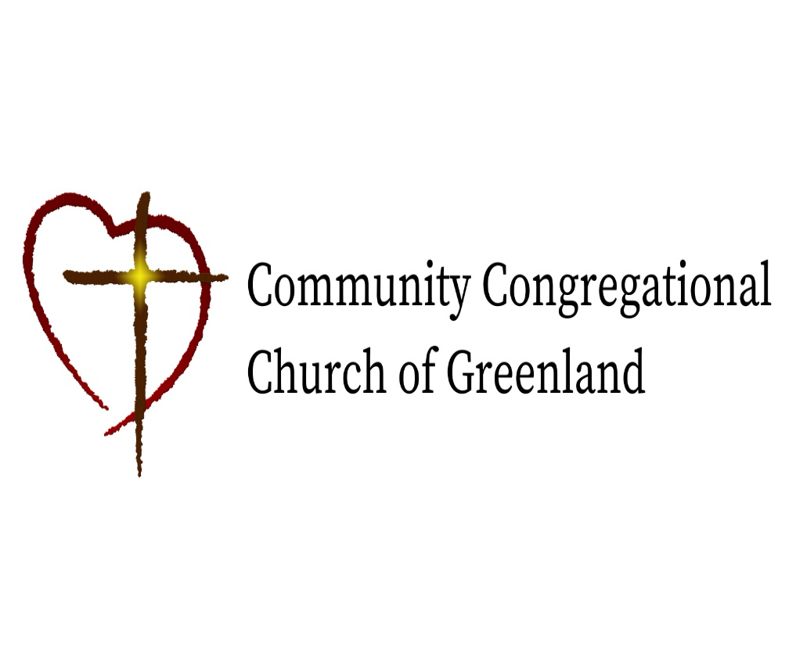

God calls us together to welcome all
and to serve God, each other, this community,
and the world
in the spirit of Christ’s love.
❖ All are welcome! 

